**Leadership & Strategies Term Project**

# 

**Submitted to:**

Ma’am Rizwana

**Submitted by:**

* Hamza Farooq (2016-CS-122)
* Sana Masood (2016-CS-153)
* Komal Shehzadi (2016-CS-178)
* Zoha Rasheed (2016-CS-374)

**Department of Computer Science and Engineering**

**UET Lahore**

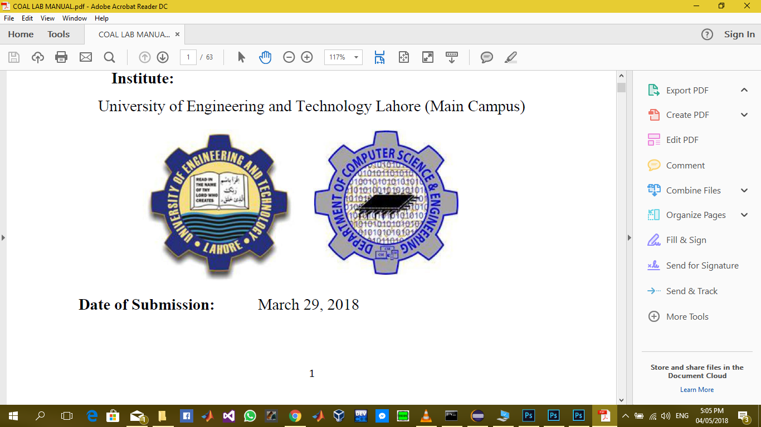

Contents

Contents 2

ABSTRACT 4

DEPTH ANALYSIS OF CURRENT SCENARIOS OF PAKISTAN 4

Situation of Doctors because of COVID-19 5

Facilitation by government of Pakistan against COVID-19 8

ESTABLISHING FUNDS FOR DESERVING PEOPLE. 11

TESTING FACILITIES IN PAKISTAN 11

ISOLATION WARDS 13

ECONOMY LOSS DUE TO COVID-19 14

'I Fear Hunger More Than the Virus': Pakistan's Delicate COVID-19 Balance 16

Faults 16

DIFFERENT LEADERS AND THEIR LEADERSHIP STRATEGIES 19

Asif Ali Zardari 19

Mian Muhammad Nawaz Sharif 21

Pervez Musharraf 23

PM Imran Khan 25

Shahbaz Sharif 28

Fazal-ur-Rehman (Molana diesel) 31

Why Molana Diesel 32

A CRITIQUE FROM THE LEADERSHIP AND STRATEGIC POINT OF VIEW: 32

Flaws of Asif Ali Zardari 32

Flaws of Mian Muhammad Nawaz Sharif 33

Flaws of Pervez Musharraf 34

Flaws of Imran Khan: 34

Flaws of Shehbaz Sharif: 35

Flaws of Molana Fazal Ur Rehman: 36

CORRUPTION AND ITS IMPACT ON SOCIETY 38

Abstract. 38

INTRODUCTION: 38

GENESIS OF CORRUPTION IN PAKISTAN 41

REMEDIES FOR COVID-19 44

Steps to Curtail Corruption in Pakistan 45

EFFORTS TO CURB CORRUPTION 47

CONCLUSION AND RECOMMENDATIONS 49

REFERENCES 51

# 

# ABSTRACT

We are going to address some issues because of novelty COVID-19, the role of some leaders in growth and loss of Pakistan, corruption and its impact on society, steps to eradicate corruption, flaws and solutions in leadership strategies of some leaders and remedies for COVID-19.

We analyzed all the points in depth. How covid-19 is affecting Pakistan and how it is making the condition of bodies involved worse like doctors and nurses.

We had a detailed analysis of six leaders like their reforms and decisions due to which the growth of Pakistan increased or decreased and how they can improve their flaws and strategies for the development of country.

We also discussed the root reasons of corruption in society and how can we curtail it by taking certain steps.

Finally, we have suggested some remedies for corruption and COVID-19. In our conclusion, we have discussed how we can make Pakistan a better place by following certain leadership skills.

# DEPTH ANALYSIS OF CURRENT SCENARIOS OF PAKISTAN

The current scenario of Pakistan isn't satisfactory as Pakistan is far populated country which needs more facilitation. Pakistan may be a developing country where the financial position isn't better as compared to China, USA, UK, Russia to combat with COVID-19 outbreak.

COVID-19 is a pneumonia-like disease with symptoms including fever, dry cough and shortness of breath that was first identified in Wuhan, China. The disease is caused by a new coronavirus, named SARS-CoV-2, that is similar to the virus that causes Severe Acute Respiratory Syndrome (SARS).

As per the Ministry of Health, administration of Pakistan, there are aggregate of 80,114 affirmed positive cases in the nation with in excess of 4065 new cases on Wednesday, June 3, 2020. The most noteworthy cases showed up in the Punjab area (29,489) out of which 7,469 are cured and absolute passing are 570 trailed by Sindh (31,086) out of which 15,538 are recovered and passing are 526. Khyber Pakhtunkhwa (10,897) out of which 3085 are recovered and all out passing’s happened are 490 , Baluchistan (4,740)out of which 1733 are recouped and 49 are dead, Gilgit Baltistan (738) recovered are 527 and complete passing are 11, Federal (2893) has 169 recuperated and 30 passing and Azad Kashmir have 271 affirmed cases out of which 6 are dead and 127 are cured. The outcomes appeared in figure [1]

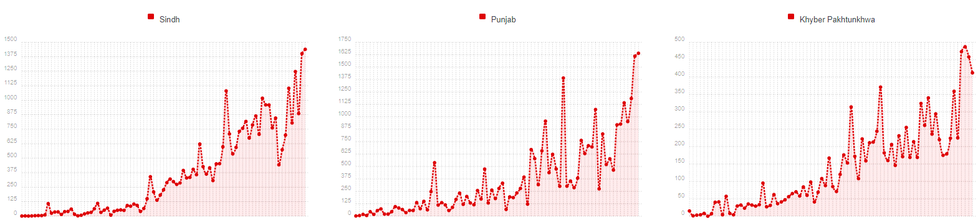

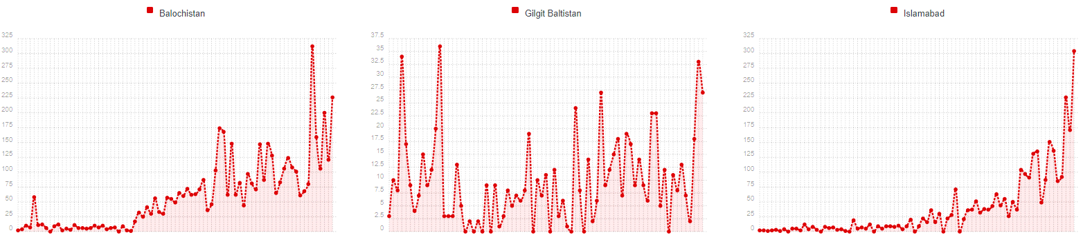

## Situation of Doctors because of COVID-19

Doctors in Pakistan are warning that the country's already weak healthcare system could soon be overwhelmed by coronavirus patients.

So far, with fewer than 2,000 deaths, the outbreak hasn't been as deadly as some initially feared. But with the rates of new cases and new fatalities at their highest levels yet, and lockdown restrictions lifted, doctors say intensive care units are now being stretched almost to capacity in many major hospitals.

In Karachi, a city of 15 million people, data shows only a handful of ICU beds still available for Covid-19 patients. Whilst in Lahore, a doctor recounted to the BBC being forced to turn away a patient who needed a ventilator, after he had already been rejected by two other hospitals. Medics in Peshawar and Quetta described being under similar levels of pressure.

Officials acknowledge some hospitals are full but insist there are still large numbers of beds available elsewhere, and are making public information about where are they are, whilst new facilities are in the process of being built in Karachi. But doctors fear the number of critical cases will continue to rise, and say their efforts to treat patients are being hampered by conspiracy theories and mistrust.

"Many ill people try and stay at home… Only when their condition has gotten a lot worse do they come to the hospital," a leading doctor in Quetta told the BBC.

As a result, he said, large numbers of his patients died shortly after arrival or in the ambulance.

"They don't even give us the chance to try and treat them," he lamented.

As well as concerns about the quality of medical care, and a reluctance for family members to be quarantined, bizarre rumors are swirling around, including claims that doctors are being paid by the World Health Organization (WHO) to falsely declare patients as coronavirus sufferers.

One doctor from Karachi, who asked to remain anonymous, told the BBC she was recently contacted by a friend asking for medical advice, saying: "'My son is having flu and fever but I do not want to take him to the hospital because doctors are just declaring every fever is Covid, and they're taking 500 rupees ($3; £2.40) per case'."

The theories might sound risible, but they have dangerous consequences - and not just for the patients. Hospitals in Karachi, Peshawar and Lahore have all seen incidents of patients' families attacking staff.

* A super-spreading funeral that led to three deaths
* Why Pakistan's doctors are so angry
* The porous borders where the virus cannot be controlled

At the Jinnah Postgraduate Medical Centre in Karachi, an isolation ward was trashed by a mob when the body of a patient wasn't handed over immediately to the family. In Pakistan, funerals are normally carried out as soon as possible, as per Islamic tradition, with large numbers of mourners attending - neither of which are possible if someone dies, or is suspected of dying, with coronavirus. Dr Yahya Tunio a leading doctor at the hospital, told the BBC medical staff are "fighting both coronavirus and ignorance".

Dr Jamal Awan, who works at Mayo Hospital Lahore, told the BBC security had to be increased on the wards after a number of recent violent flare-ups. He described the incidents as being rooted in a mix of anger at a lack of resources, and a fear that doctors are secretly killing patients through "poisonous injections".

In one instance at the hospital, a family was told an ICU bed with a ventilator wasn't available for their relative, who was in a critical condition and subsequently died. A doctor on duty at the time, Amara Khalid, told the BBC that 20 to 30 members of the group attempted to attack hospital staff. She said some of the relatives shouted out angrily: "If coronavirus is real… how are you not sick?"

Her husband, also working as a doctor at the time, was pushed inside the ward, and forced to perform CPR on the patient without any safety equipment. Dr Khalid is calling for awareness to be improved about the disease, security for staff improved, and restrictions placed on the numbers of relatives allowed into hospitals.

"I felt terrible, I even thought about leaving the job after that incident but we just can't," she said. "If everybody leaves, then who is going to work?"

In fact, hundreds of doctors have been infected with coronavirus in Pakistan. At least 30 healthcare workers are reported to have died from it.

At one major hospital in Peshawar, the entire gynecological department was temporarily closed down after an outbreak amongst staff. A doctor from the hospital told the BBC about 100 of his colleagues had tested positive in total, the vast majority of whom were not even directly working with coronavirus patients.

He added that whilst levels of protective equipment had improved, he was sharing a face shield with colleagues, taking turns to use it on their respective shifts. Like many other doctors, he raised particular concerns about the lack of kit handed out to staff who aren't, in theory, on the frontline against the virus, but remain exposed by caring for patients who may have been infected but have never been tested.

Many doctors fear the worst is yet to come, and have expressed frustration with the decision to lift the bulk of lockdown restrictions last month.

Dr Rizwan Saigol, who works at the Mayo Hospital in Lahore, told the BBC that even prior to the pandemic he had seen families "begging for ventilators". Now, he said, the situation feels "really scary". If the number of cases continues to rise, he added, "our hospitals will get exhausted… We do not have enough ICUs or ventilators".

Prime Minister Imran Khan, however, has insisted the cost of a lockdown is simply too severe for those in the country already living a hand-to-mouth existence.

"Twenty-five per cent of our population lives below the poverty line - that means there are 50 million people who can't afford to eat two meals a day… If we implement a lockdown like they had in Wuhan or Europe, what will happen to them?" he asked during a televised address earlier this week.

Mr. Khan has appealed to people to follow social distancing rules, and face masks have been made compulsory in public. But he has clashed at times with local authorities like those in opposition-controlled Sindh province who were the first to impose strict restrictions on movement back in March.

Many healthcare workers, like Dr Yahya Tunio, from the Jinnah Postgraduate Medical Centre in Karachi, say they have seen a "surge in cases since lockdown restrictions were eased" a few weeks ago.

Dr Tunio told the BBC that ICU beds in the hospital, one of the largest in the city, were "full", and that new patients were regularly having to be diverted elsewhere for critical care, even though most other hospitals are also in a similar state. "It is stressful and tense," he added.

Another medic in Karachi, worried about infecting her relatives at home, and exhausted from long hours of work in a hazmat suit in high temperatures, described her feelings on seeing the continued large number of people on the streets.

"It's heart wrenching… why are we going through all that for these people who just don't care about themselves, who blame us for taking bribes?"

"Still," she said, "we are doing it for them."

## Facilitation by government of Pakistan against COVID-19

The Government of Pakistan is taking all the measures against the COVID-19 to give and guarantee the obligations of the state for their kin. Since the principal day when the primary case was accommodated in Karachi city of Sindh all the administrations and measures were utilized with the extraordinary capacities to guarantee the safeness of life in the locale. In the meantime, all the cases have a movement history, recommending transmission somewhere else being imported in the nation. The administration of Pakistan furnishes the COVID-19 moderation procedures with their measures. For example, early case recognition and Tracing and following of contacts, Risk correspondence, Social Distancing, Quarantine and Isolation to dodge the spread of COVID-19. A lot of papers are published about Covid-19 and still studies have been conducting related to the cure, advancement, prevention or treatment of this outbreak. Telecommunications, print media and electronic media helps in establishing the slogan “Stay Home, Stay Safe” also they have elaborated the precautionary rules to prevent people from affecting with Covid-19. Prime Minister “Imran Khan” address his nation after every specified intervals in order to update the scenarios Pakistan is facing these days. He motivated the public to stay calm, determined and preventive for corona. These factors highly helped for spreading awareness related to Covid-19. Preventive Rules are following.

****Wash your Hands

* Wash your hands regularly with cleanser and water for at any rate 20 seconds particularly after you have been in an open spot, or in the wake of cleaning out your nose, hacking, or wheezing.
* If cleanser and water are not promptly accessible, utilize a hand sanitizer that contains at any rate 60% liquor. Spread all surfaces of your hands and rub them together until they feel dry.
* Avoid contacting your eyes, nose, and mouth with unwashed hands.

Avoid close contact

Avoid close contact with individuals who are wiped out, even inside your home. On the off chance that conceivable, keep up 6 feet between the individual who is debilitated and other family unit individuals.

1. Put separation among yourself and others outside of your home.
2. Remember that a few people without side effects might have the option to spread infection.
3. Stay in any event 6 feet (around 2 a manageable distance's) from others
4. Do not accumulate in gatherings.
5. Stay out of crowded places and avoid mass gatherings.
6. Keeping distance from others is especially important for people who are at higher risk of getting very sick

Cover your mouth and nose with a cloth face cover when around others

* Keeping good ways from others is particularly significant for individuals who are at higher danger of becoming ill
* Spread your mouth and nose with a material face spread when around others
* You could spread COVID-19 to others regardless of whether you don't feel debilitated.
* Everyone should wear a material face spread when they need to go out in broad daylight, for instance to the market or to get different necessities.
* Cloth face covers ought not be set on little youngsters under age 2, any individual who experiences difficulty breathing, or is oblivious, debilitated or in any case unfit to evacuate the veil without help.
* The material face spread is intended to ensure others in the event that you are contaminated.
* Do NOT utilize a facemask implied for a social insurance specialist.
* Continue to keep around 6 feet among yourself as well as other people. The material face spread is certainly not a substitute for social removing.

****Cover coughs and sneezes

* If you are in a private setting and do not have on your cloth face covering, remember to always cover your mouth and nose with a tissue when you cough or sneeze or use the inside of your elbow.
* Throw used tissues in the trash.
* Immediately wash your hands with soap and water for at least 20 seconds. If soap and water are not readily available, clean your hands with a hand sanitizer that contains at least 60% alcohol.

Clean and disinfect

* Clean AND disinfect frequently touched surfaces daily. This includes tables, doorknobs, light switches, countertops, handles, desks, phones, keyboards, toilets, faucets, and sinks.
* If surfaces are dirty, clean them. Use detergent or soap and water prior to disinfection.
* Then, use a household disinfectant.

Researches [2] and all the observations have concluded that most young people and old people are the most vulnerable towards Covid as the immunity level is low in them, chances to get viral diseases is higher in them as compared to others. Therefore children and old ones are at major risk, following is the analysis of Covid patients related to their age. [3]

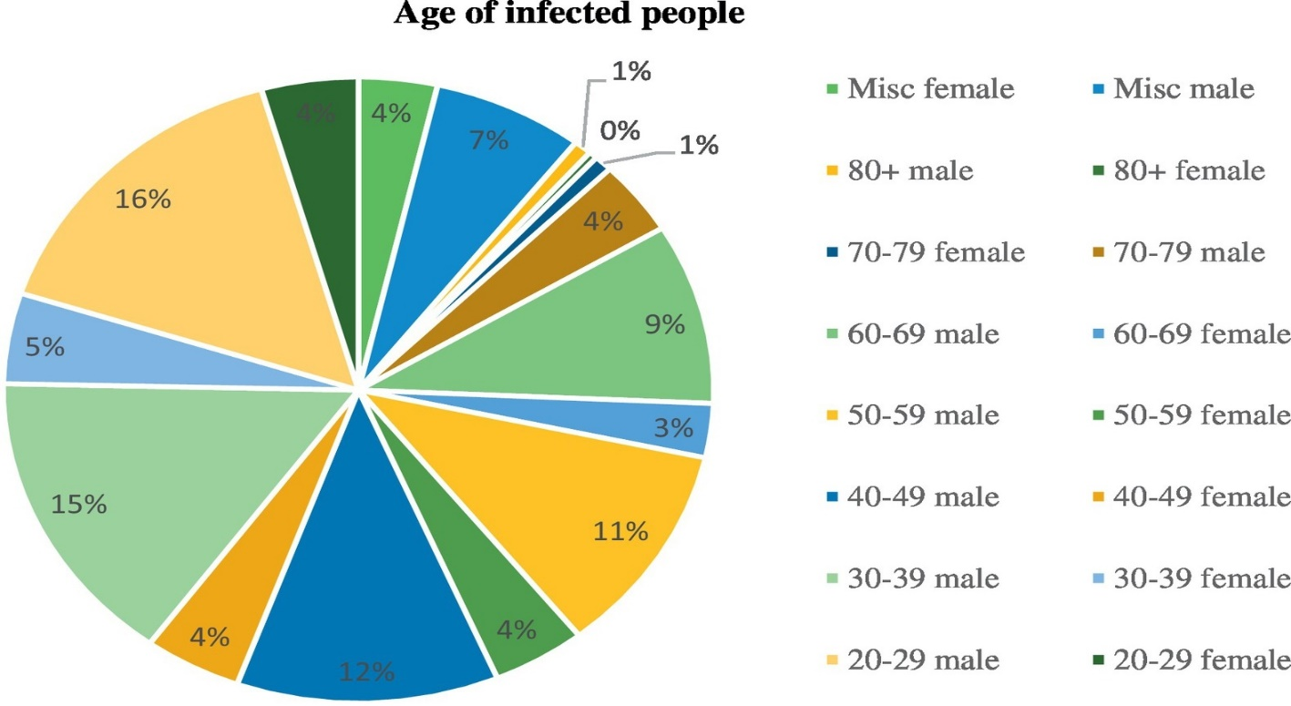

Gender distribution w.r.t to age infected by COVID-19 in Pakistan.

## ESTABLISHING FUNDS FOR DESERVING PEOPLE.

The Government of Pakistan has established a COVID-19 Relief Fund to receive donation for the welfare of publics. Social network helplines were launched by the Government in seven (07) local languages. Communication Task Force Baluchistan with the support of UNHCR has developed IEC material in Dari and Pashto Languages. The materials will be distributed in all villages with refugees in Baluchistan. The Government of Khyber Pakhtunkhwa has issued directives for closure of OPDs and elective surgical services from 1-13 April 2020 in all the Tertiary Care Hospitals, District Headquarters Hospitals and Private Clinics throughout the province. The Central Emergency Relief Fund (CERF) has allocation $ 60 million to Global Response plan for COVID-19. Sindh Government has established first drive through COVID-19 Testing facility in Karachi.

## TESTING FACILITIES IN PAKISTAN

Globally PCR is used for COVID-19 test which are the best and easy method, so Pakistan's government also recommends PCR method. In different cities across the country 15 (ICT-01, Balochistan-01, KP-01, Punjab-04, Sindh-05, AJK-01, GB-01 and NIH mobile testing lab deployed in Taftan) laboratories have been equipped with free PCR system facilities for COVID-19 test. Pakistan's testing capacity has been increased from 30,000 to 280,000 and would be further enhanced to 900,000. Since the outbreak the country has carried out nearly 15,000 coronavirus tests. [4] In order to improve the testing efficiency, National Disaster Management Authority (NDMA) works with National Institute of Health (NIH) to rise the current number of coronavirus testing laboratories from 15 to 50. The new testing labs would be set in different cities across the country. Pakistan is also launching a training program for paramedics and laboratory staff to resolve the deficiency. NDMA would recruit 100 lab technicians with expertise in molecular biology

Here are the details of WHO designated COVID-19 test centers in different cities of Pakistan. All these test centers will share the data of coronavirus patients with NIH.

**Karachi (**Aga Khan University Hospital**,** Jinnah Post Graduate Medical Center), **Quetta (**Fatima Jinnah Chest and General Hospital**,** Sheikh Khalifah Bin Zayyad Hospital), **Lahore (**Services Hospital)**, Islamabad** (PIMS), **Peshawar**(Police Services Hospital)

**Sample Collection Facilities**

There are other medical facilities across the country that are collecting samples to facilitate citizens. These samples are sent to the main testing facilities listed above. These sample collection facilities are listed below:

**Punjab-** Services Hospital Lahore, Nishtar Hospital, Multan, Benazir Hospital – Rawalpindi

**AJK-** Shaikh Khalifa bin Zayed Al Nahayan Hospital, Muzaffarabad, Abbas Institute of Medical Sciences. Muzaffarabad, Shaikh Khalifa bin Zayed Al Nahayan Hospital – Rawalakot and Divisional Headquarters Hospital – Mirpur.

**SINDH-** Chandka Medical College Hospital, Larkana, Muhammad Mahar Medical College, Sukkur, Civil Hospital, Karachi

**GILGIT BALOSHISTAN-** GB allows people to contact district health authorities who will visit the patient’s home to collect samples.

**KHYBER PAKHTUNKHUWA-** Police Services Hospital

The Health Ministry has urged citizens exhibiting flu-like symptoms to undergo tests for coronavirus at the designated test centers. The Ministry has once again directed the citizens to undertake precautionary cautions to avoid contracting the disease and to report suspected coronavirus cases at the dedicated helpline **1166**.

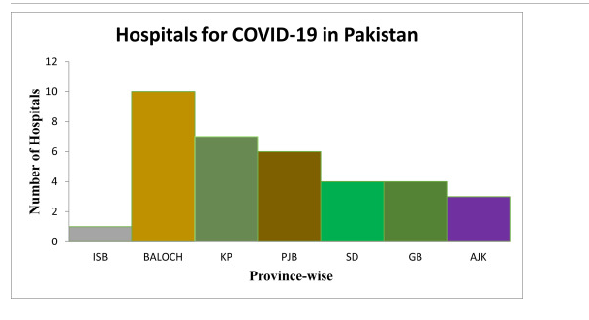

## ISOLATION WARDS

The Quarantines being used to restrict the activities or separation of persons (in a non-health care facility) who were not ill yet, but who might have been exposed to [5] an infectious agent or disease such as COVID 19 with the objective of monitoring symptoms and early detection of cases. The places use for Quarantine of COVID-19 people was widely disturbed in provinces. The total number of Quarantine's [6] 23,557 in 139 districts of the Pakistan which arise the good gesture which being use in this scenario throughout Pakistan to control the outbreak of COVID-19. In Islamabad the capital of the country, have allotted the two quarantine facilities. In the Baluchistan, there were 10, Khyber Pakhtunkhwa 52, Punjab 6, Sindh 2, while Gilgit-Baltistan 63 quarantine facilities were being functional. In AJK there were 4 quarantine facilities were being functional in the various districts.

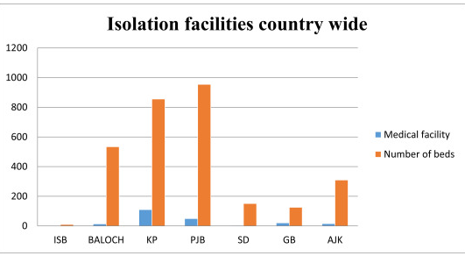

## ECONOMY LOSS DUE TO COVID-19

In recent days Pakistan’s federal government has also started to take action to deal with the economic ramifications of this crisis. A Rs.1.2 trillion (~$7 billion) economic plan has been unveiled with a focus on minimizing the economic damage on vulnerable segments of society. Under this program, direct cash support will be provided to 10 million households in the coming weeks. This will be achieved by expanding the monthly transfer received by beneficiaries of the Benazir Income Support Program (BISP) by 50 percent to Rs. 3,000 per month for the next four months, benefiting almost 4.5 million households. Secondly, 3 million additional households will be identified through the National Socio-Economic Registry (NSER) and given a cash transfer of Rs. 3,000 per month for the next four months. Finally, the government will identify an additional 2.5 million households and verify them through the local district administration setup. Once verified, these households will also be provided financial support by the federal government. In addition, the government has also announced support funds for businesses which includes Rs. 100 billion in tax refunds and an additional Rs. 100 billion in deferred interest payments. The State Bank of Pakistan has swiftly cut rates by 225 basis points in the last few days, giving breathing room to both the federal government—the largest borrower in the country—and to businesses facing cash flow problems. Provincial governments are also preparing their own financial packages and they have some fiscal room to expand the federal government’s cash transfer measures. As this crisis continues, both the federal and provincial governments will almost surely announce more measures to rescue the economy, especially for the vulnerable. All of this is happening at a time when Pakistan’s financial capacity to bear the costs of this pandemic are severely limited. This means that the country will need assistance from multilateral institutions like the IMF and the World Bank—talks are already ongoing—and from strategic allies such as China. The ongoing IMF program will also have to be renegotiated, and rightfully so, because Pakistan cannot continue to pass on the costs of a stabilization program onto its citizens at a time when its economy has come to a grinding halt. As Khurram Husain, business editor at Dawn recently wrote.

“Business as usual will not work” and dealing with this pandemic will require “every ounce of creative energy and close coordination.”

For Pakistan, this means that both domestic and external institutions must extract every ounce of boldness and creativity to rescue and re-stabilize the country’s economy. Pakistan could expect between 12.3 million to 18.5 million cutbacks in various areas of economy in the consequence of a halfway or complete shutdown because of the countrywide flare-up of the coronavirus, revealed The News on Tuesday. Three famous market analysts having a place with the Pakistan Institute of Development Economics (PIDE), to be specific Dr Nasir, Naseem Faraz and Mahmood Khalid, illustrated their discoveries in an exploration paper. The paper featured three phases through which the effect of the infection on the economy could be comprehended. The normal month to month loss of Stage-I was evaluated at Rs22 billion, Stage-II at Rs187 billion and Stage-III at Rs261 billion. [7] The assessed money related estimation of the loss in every division of the economy was additionally determined. The specialists exhorted the administration to consider potential systems to connect with laid-off laborers. It merits referencing here that the assessed layoffs in the examination are month to month misfortunes. As the time of lockdowns broaden, the layoffs would likewise increment relatively. As indicated by specialists, if the lockdown of cities continued for months then the monthly loss can be mitigated. The scientists asserted that administration utilizes every one of its assets to follow the infection spread to make firewalls through specific lockdowns so as to hold the losses down. [2] These lockdowns would have financial impacts which could develop through a few channels, including, yet not restricted to, sharp decreases in residential interest, diminished the travel industry and business travel, production and supply linkages and health effects," The research proposed [8]under Stage-I the education, hospitality, wholesale and retail trade sectors would be highly concerned. Job losses in these sectors have already started. The most hit sectors in Stage II would be the dealings by discount and retail exchange, agribusiness, assembling, transport and interchanges. Susceptible employment is high in these sectors and they are also more sensitive to lockdowns. Based on the calculation, the bulk of loss as a results of the economic shutdown would be of daily-wage workers because they're going to be unable to earn. [9]  [10]

The investigation featured a few potential approaches to address the emergency, some of which are recorded beneath.

* Out-of-the-box solutions for doing business are needed. For example, it is evaluated that restaurants are going to look up to 20% reduced sales. Government ought to reduce GST on the sales of takeaways.
* Directed credits at lower cost can be given to those organizations which utilize day by day and low pay laborers to make up for the yield loss while still working with a specific number of laborers.
* Such pandemics have short and long-run financial costs identified with them. Thinking about the low to zero real growth scenario, significant tax collection shortage will happen both this year and in the next fiscal year. The present tax collection target will need to be revised downward to prevent the FBR from superfluous revenue pursuit.
* For providing relief to businesses which engage the most vulnerable workers (especially daily wage workers) the GST on their items should be waived.
* For exporters whose containers are abandoned at sea or importers have asked to delay their work for 6 months, the government should give six months to convert letters of credit on zero rate, relying on the prerequisite that they won't lay off their laborers.

## 'I Fear Hunger More Than the Virus': Pakistan's Delicate COVID-19 Balance

People are unable to go back to their respective towns as drivers are charging multiple times more for the excursion than expected because of the lockdown. Other factors putting pressure on the lockdown are Pakistan's strong social ties and traditions, which pose major hurdles to restrictions on social and physical contacts • .Marriage ceremonies and celebrations -- often very large affairs -- have already been banned in cities, but people are still arranging weddings and parties and inviting people to them in rural areas. Schools and Universities are all closed and teachers and their employees working there are unemployed they are not provided with their salary also students are not finding it a proper way to get education through online platforms. [11]. The stress has driven numerous to identify with Pakistani Prime Minister Imran Khan's restriction to an exacting national lockdown in a nation where around one-fourth of its kin procure just 300 rupees (generally $2) every day. Daily wagers are unable to earn their livelihood [12] and are afraid they will be died because of hunger rather than Corona. With Pakistan under a disagreeable lockdown planned for battling the coronavirus pandemic seething far and wide, an enormous part of the nation's passionate and neediness stricken individuals are opposing cutoff points on physical and social contacts and their versatility. There are three central point that make Pakistan's lockdown hard to authorize - a stressed economy with countless individuals living in neediness, the solid social ties and conventions in the nation, and the ardent strict convictions in huge portions of the populace. [13]

## Faults

* Pakistan is not financially secure country who can easily accommodate the economic loss due to lockdown; It has to take loan and assistance from other countries. The amount of loan taken from other countries is increased.
* The nearly $2 trillion stimulus package known as the Coronavirus Aid, Relief and Economic Security (CARES) [14] Act gives significant relief to student loan borrowers. Under the CARES Act, which was passed in response to economic hardship caused by the coronavirus (COVID-19) pandemic, federal student loan borrowers do not have to make payments for a period for six months. Additionally, federal student loan interest rates are set at 0% during that time.
* The ADB and cash-strapped Pakistan have finalized a USD 305 million emergency COVID-19 loan to help the country buy medical equipment and disburse money to poor women, according to a media report on Wednesday. The Asian Development Bank will extend the loan on commercial terms, [15] The Express Tribune reported1 Last month, Pakistan had received an emergency loan of USD 1.39 billion from the International Monetary Fund (IMF) and an aid of USD 200 million from the World Bank (WB).
* While the IMF loan was to boost Pakistan's foreign exchange reserves in the wake of the coronavirus crisis, the WB aid focused on supporting preparedness and emergency response in the health sector.  
  The European Union has offered an aid package of more than USD 163 million to cash-strapped Pakistan to tackle the COVID-19 pandemic and to boost the country’s economic and security developments [16]
* Public is not taking this deadly disease serious because of this they are violating rules.With the number of coronavirus cases and deaths increasing and people having severely violated standard operating procedures (SOPs) for Covid-19 during the Eid holidays, the government is considering resuming the lockdown across the country. [17]
* Public gatherings are still taking place where risk of getting virus is higher.
* People are not taking any preventive precautions as it makes their life difficult. They feel suffocated while staying at their home and this leads to their arrival on roads and other places
* All Universities, Schools, Academies, Tuitions are closed due to which students are unable to continue their education. [18] due to the ongoing coronavirus crisis, the government has decided to close educational institutes until July 15 while cancelling board exams until the end of this year. Education Minister Shafqat Mehmood addressed media after a session of the National Coordination Committee today. In his address, the minister said that the government had earlier decided to close educational institutions until May 31 but then it approved an extension until the mid of July. [19]

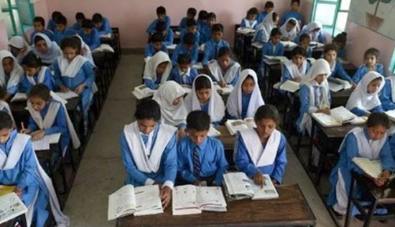

* Proper Lockdown hasn’t made possible so that number of patients per day increases. [20] Lockdown has lifted one week before Eid Ul Azha, because of this people are going back to their normal routine.
* Daily Wagers have lost their livelihood because of the complete lockdown. Not only are they unable to feed their families also, they are at higher risk of death due to fewer facilities they are provided.
* Minister of State for Health Dr Zafar Mirza on Sunday 1 June 2020 [21]dispelled the impression that there was a shortage of hospital beds, ventilators or other facilities for Covid-19 patients.

“Only 28% of the available ventilators are currently being used for coronavirus patients,”

he said while addressing a news conference. “There are 723 patients who are in a critical condition and 201 of them are on ventilators,” he added

* All utilities store are not taking precautions and fulfilling SOP [22]provided by Government, PM has made a committee for keeping in view whether public, traders, shopkeepers and sales are according to the rules that is provided? But all in vain the shops in small areas or in street are negotiating with it.
* Students are unable to study well due to the lack of management for providing online education.

# DIFFERENT LEADERS AND THEIR LEADERSHIP STRATEGIES

## Asif Ali Zardari

**Asif Ali Zardari** (born 26 July 1955) is a Pakistani politician who is the president of Pakistan People’s Party Parliamentarians and was the co-chairperson of Pakistan People's Party. He served as the 11th President of Pakistan from 2008 to 2013, the first president born after Partition. He is member of National Assembly of Pakistan since August 2018.

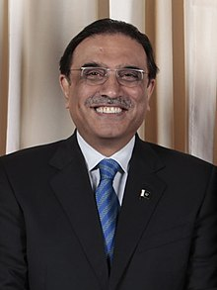

The son of Hakim Ali Zardari, a landowner from Sindh, Zardari rose to prominence after his marriage to Benazir Bhutto in 1987, who became the Prime Minister of Pakistan after her election in 1988. When Bhutto's government was dismissed by President Ghulam Ishaq Khan in 1990, Zardari was widely criticized for involvement in corruption scandals that led to its collapse. When Bhutto was reelected in 1993, Zardari served as Federal Investment Minister and Chairperson of Pakistan Environmental Protection Council. Following increasing tensions between Bhutto's brother Murtaza and Zardari, Murtaza was killed in a police encounter in Karachi on 20 September 1996. Bhutto's government was dismissed a month later by President Farooq Leghari, while Zardari was arrested and indicted for Murtaza's murder as well as corruption charges.

Although incarcerated, he nominally served in Parliament after being elected to the National Assembly in 1990 and Senate in 1997. He was released from jail in 2004 and went into self-exile to Dubai, but returned when Bhutto was assassinated on 27 December 2007. As the new Co-Chairman of the PPP, he led his party to victory in the 2008 general elections. He spearheaded a coalition that forced military ruler Pervez Musharraf to resign, and was elected President on 6 September 2008. He was acquitted of various criminal charges the same year.

As president, Zardari remained a strong American ally in the war in Afghanistan, despite prevalent public disapproval of the United States following the Raymond Davis incident and the Nato attack in Salala in 2011. Domestically, Zardari achieved the passage of the Eighteenth Amendment in 2010, which constitutionally reduced his presidential powers. His attempt to prevent the reinstatement of Supreme Court judges failed in the face of massive protests led by his political rival Nawaz Sharif. The restored Supreme Court dismissed the PPP's elected Prime Minister Yousaf Raza Gillani for contempt in 2012 after Gillani refused to write to the Government of Switzerland to reopen corruption cases against Zardari. Zardari's tenure was also criticized for mishandling nationwide floods in 2010, and growing terrorist violence. Following multiple bombings of Hazaras in Quetta in early 2013, Zardari dismissed his provincial government in Baluchistan.

Towards the end of his term, Zardari recorded abysmally low approval ratings, ranging from 11 to 14%. After the PPP was heavily defeated in the 2013 general election, Zardari became the country's first elected president to complete his constitutional term on 9 September 2013.His legacy remains divisive, with political observers accusing his administration of corruption and cronyism.

His slogan of “awam khappay” got so famous that it was used to mimic him in many tv shows. “awaam khappay” in Seraiki means “people grow” but it was used to mock him because of his poor leadership skills. In his time, economy of Pakistan decreased so much that everything including food and basic necessities became very expensive and that loss in economy was so large that people in Pakistan are still paying huge taxes because of that. Everyone is in debt because of him lacking the good leadership skills.

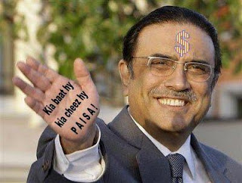

Because of his poor skills Pakistan became a very poor country that is why he is considered as a corrupt leader in Pakistan.

## Mian Muhammad Nawaz Sharif

**Mian Muhammad Nawaz Sharif** (born 25 December 1949) is a Pakistani businessman and politician who served as the prime minister of Pakistan for three non-consecutive terms. Sharif is the longest-serving prime minister of Pakistan having served a total of more than 9 years.

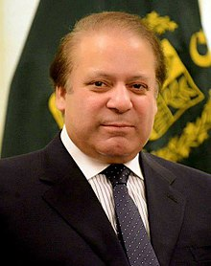

Born into the upper-middle class Sharif family in Lahore, Sharif is the son of Muhammad Sharif, the founder of Ittefaq and Sharif Group. He is the elder brother of Shehbaz Sharif, who also served as the chief minister of Punjab. According to the Election Commission of Pakistan, Sharif is the one of the wealthiest men in Pakistan, with an estimated net worth of at least 1.6 billion Pakistani rupees. Most of Sharif's wealth originates from his businesses in steel construction.

Before entering politics in the 1970s, Sharif studied business at Government College and law at the University of Punjab. In 1981, Sharif was appointed by President Zia as the minister of finance for the province of Punjab. Backed by a loose coalition of conservatives, Sharif was elected as the Chief Minister of Punjab in 1985 and re-elected after the end of martial law in 1988. In 1990, Sharif led the conservative Islamic Democratic Alliance and became the 12th prime minister of Pakistan.

After being ousted in 1993, when president Ghulam Ishaq Khan dissolved the National Assembly, Sharif served as the leader of the opposition to the government of Benazir Bhutto from 1993 to 1996. He returned to premiership after the Pakistan Muslim League (N) (PML-N) was elected in 1997, and served until his removal in 1999 by military takeover and was tried in plane hijacking case which was argued by Barrister Ijaz Hussain Batalvi assisted by Khawaja Sultan senior Advocate, Sher Afghan Asdi and Akhtar Ali Kureahi Advocate. After prison and exile for more than a decade, he returned to politics in 2011 and led his party to victory for a third time in 2013.

In 2017, Sharif was removed from office by the Supreme Court of Pakistan regarding revelations from the Panama Papers case. In 2018, the Pakistani Supreme Court disqualified Sharif from holding public office, and he was sentenced to ten years in prison.

People in Pakistan specially in Lahore believed in him so much that is why his slogan “ek waari ferrr sherrr” got so famous it means he was so sure he is going to be elected again. That was the only reason he became the prime minister of Pakistan thrice.

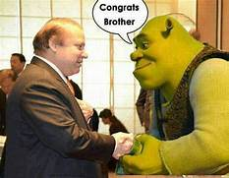

Sooner people came to know about his corruption and panama cases. He was doing money laundering behind the very big projects of Pakistan. His steel mills were selling steel for Pakistan’s projects like metro and orange train and the amount they were receiving was so great more than the actual price of steel. Then his panama cases were revealed so it was proved that he was the most corrupt leader of Pakistan. He made many reforms in Pakistan but still the loss Pakistan faced because of him was much bigger. Then “Go Nawaz Go” slogan got so famous. People were so furious they stopped voting PMLN and started this slogan to eradicate the roots of this corrupt leader who later was sentenced to prison for ten years but he is on bail for health reasons right now.

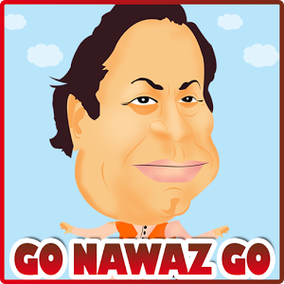

Imran Khan Niazi was the main reason why his corruption got revealed. He worked so hard to show his true face but there are still some people who believe in him because of his reforms.

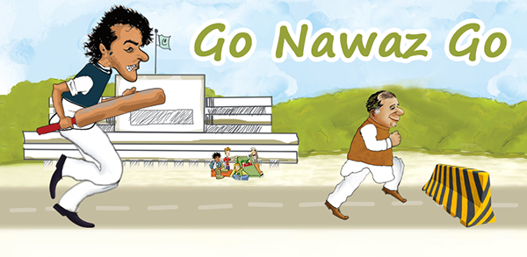

## Pervez Musharraf

**Pervez Musharraf** (born 11 August 1943) is a Pakistani former four-star general a military dictator and who became the tenth president of Pakistan after the successful 1999 Pakistani coup d'état. He held the presidency from 2001 until 2008, when he tendered his resignation to avoid impeachment.

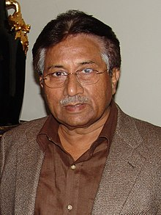

Born in Delhi during the British Raj, Musharraf was raised in Karachi and Istanbul. He studied mathematics at Forman Christian College in Lahore and was also educated at the Royal College of Defense Studies in the United Kingdom. Musharraf entered the Pakistan Military Academy in 1961 and was commissioned to the Pakistan Army in 1964, playing an active role in the Afghan civil war. Musharraf saw action during the Indo-Pakistani War of 1965 as a second lieutenant. By the 1980s, he was commanding an artillery brigade. In the 1990s, Musharraf was promoted to major general and assigned an infantry division, and later commanded the Special Services Group. Soon after, he also served as deputy military secretary and director general of military operations.

Musharraf rose to national prominence when he was promoted to four-star general by Prime Minister Nawaz Sharif in 1998, making Musharraf the head of the armed forces. He led the Kargil infiltration that almost brought India and Pakistan to a full-fledged war in 1999. After months of contentious relations between Sharif and Musharraf, Sharif unsuccessfully attempted to remove Musharraf as the army's leader. In retaliation, the army staged a coup d'état in 1999, which allowed Musharraf to take over Pakistan as president in 2001. He subsequently placed Sharif under strict house arrest before launching official criminal proceedings against him.

Musharraf initially remained the Chairman of the Joint Chiefs and the Chief of the Army Staff, relinquishing the former position upon confirmation of his presidency. However, he remained the Army Chief until retiring in 2007. The initial stages of his presidency featured controversial wins in a state referendum to grant him a five-year term limit, and a general election in 2002. During his presidency, he advocated for the Third Way, adopting a synthesis of conservatism and socialism. Musharraf reinstated the constitution in 2002, though it was heavily amended within the Legal Framework Order. He appointed Shaukat Aziz to replace Sharif in 2004, and oversaw directed policies against terrorism, becoming a key player in the American-led war on terror.

Musharraf pushed for social liberalism under his enlightened moderation program and promoted economic liberalization, while he also banned trade unions. Musharraf's presidency coincided with a rise of overall gross domestic product by around 50%; in the same period, domestic savings declined, and economic inequality rose at a rapid rate. Musharraf's government has also been accused of human rights abuses, and he survived a number of assassinations attempts during his presidency. When Aziz departed as prime minister, and after approving the suspension of the judicature in 2007, Musharraf's position weakened dramatically. Tendering his resignation to avoid impeachment in 2008, Musharraf emigrated to London in a self-imposed exile. His legacy as leader is mixed; he saw the emergence of a more assertive middle class, but an open disregard for civilian institutions greatly weakened Pakistan.

Musharraf returned to Pakistan in 2013 to participate in that year's general election, but was disqualified from participating after the country's high courts issued arrest warrants for him and Aziz for their alleged involvement in the assassinations of Nawab Akbar Bugti and Benazir Bhutto. Upon Sharif's re-election in 2013, he initiated high treason charges against Musharraf for implementing emergency rule and suspending the constitution in 2007. The case against Musharraf continued after Sharif's removal from office in 2017, the same year in which Musharraf was declared an "absconder" in the Bhutto assassination case by virtue of moving to Dubai. In 2019, Musharraf was sentenced to death in absentia for the treason charges,although, the death sentence was later annulled by the Lahore High Court.

Pervez Musharraf rural time was the golden time for Pakistan. The economy of Pakistan increased most and people in Pakistan got so many jobs and scholarships because of his good leadership strategies. He was a good leader but because of his elicits illegal activities as a general he got arrested and punished.

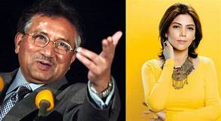

## PM Imran Khan

Imran Ahmed Khan Niazi HI PP is the 22nd and current Prime Minister of Pakistan and the chairman of the Pakistan Tehreek-e-Insaf. Before entering politics, Khan was an international cricketer and captain of the Pakistan national cricket team, which he led to victory in the 1992 Cricket World Cup.

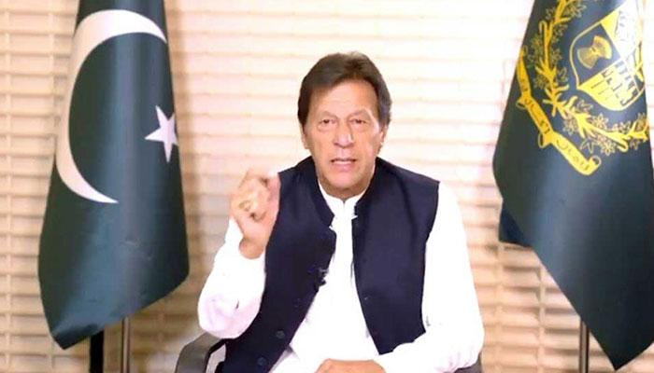

“We will have to take tough, painful decisions to shore up economy. The nation should not despair, as corrupt people are spreading disappointment and despondency for their own political mileage,” said the premier.

But there is another side to his story.

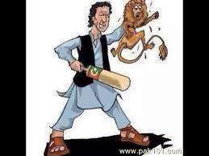

Some people and facts also comment about him being corrupt

 Imran Khan is corrupt as per definition of corruption “having or showing a willingness to act dishonestly in return for money or personal gain” he is popular in Pakistan because of his lies, because of this, he is often called the “U-Turn Khan”. Khan himself said, a great leader always takes U-turns. During his first 9 months, his sisters made billions. His one sister is convicted by courts in Pakistan. Khan has 4 palaces in Pakistan which includes one mountain located in the prime location of Islamabad. There are allegations on him that his sister (Who does not have any job) own 4 flats in the USA, 3 in UK & several properties in UAE which are basically owned by Khan.

Now as prime minister he has appointed all his friends on important positions. Below is the damage or corruption cases which are against Imran Khan in courts. The cases are freeze now because of his influence. It is expected that Imran Khan will prove the biggest scam one he is out from the government.

1-BRT (Billions lost, Imran Khan said we will complete it in 6 months in 30 Billion, So far it has cost 140 billion and yet it's not complete). As per people of Peshawar, this project damaged more their businesses than Afghan war.

2- Billion Tree Tsunami ( Billions corruption as per the 2019 audit report, This was Imran khans first project.)  
3- Ehtesab Commission Closure (80 Million loss)  
4- Malam Jabba Land Scam ( Former CM KPK & PM under Nab Investigation)  
5- Ghost Schools ( Audit report 2019)  
6- 42000 Ghost Students with monthly payments ( Audit report 2019)  
7- Mines (Incompetency, corruption, illegal use of authority)  
8- Khyber Bank (Nepotism, corruption)  
9- PEDO (Nepotism, corruption)  
10- LNG shipment Return (Nepotism, corruption)  
11- Use of furnace oil (Incompetency, corruption)  
12 Medicine hike ( Corruption case on the federal minister, Imran khan being prime minister unaware who did it )

## Shahbaz Sharif

Mian Muhammad Shahbaz Sharif is a Pakistani politician who is the current Leader of the Opposition in the National Assembly of Pakistan, in office since 20 August 2018.

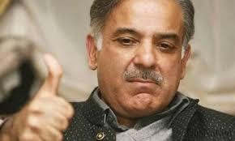

Some of the projects done during reign of Shahbaz shareef are:

[Punjab Educational Endowment Fund](https://en.wikipedia.org/wiki/Punjab_Educational_Endowment_Fund) a scholarship fund for students

[Lahore Metro Bus System](https://en.wikipedia.org/wiki/Lahore_Metro_Bus_System) The project was initiated by Pervez Elahi Govt in 2005. But only feasibility was done during his tenure. The Shahbaz Sharif Govt. delayed the project and instead of all four routes for which feasibility was completed, went for only one route of 27 km Bus Rapid Transit (BRT) system from Gajumata to Shahadra.

[Danish Schools](https://en.wikipedia.org/wiki/Danish_Schools) is a free education project to provide top class education to the less fortunate in Pakistan

Apna Rozgar Scheme is initiative taken by Punjab Govt. in order to give 50,000 yellow Taxi's yearly

Khud Rozgar Scheme is a loan scheme in which interest-free loans are provided to poor people to establish small shops or other locally operative business.

[Punjab Mass Transit Authority](https://en.wikipedia.org/wiki/Punjab_Mass_Transit_Authority)[[31]](https://en.wikipedia.org/wiki/Chief_Ministership_of_Shehbaz_Sharif#cite_note-31) to construct, maintain rapid bus transit systems in [Punjab](https://en.wikipedia.org/wiki/Punjab,_Pakistan)

[Punjab Food Authority](https://en.wikipedia.org/wiki/Punjab_Food_Authority)[[32]](https://en.wikipedia.org/wiki/Chief_Ministership_of_Shehbaz_Sharif#cite_note-32) to control food hygiene in [Punjab](https://en.wikipedia.org/wiki/Punjab,_Pakistan)

Punjab Information Technology Board to promote IT field in [Punjab](https://en.wikipedia.org/wiki/Punjab,_Pakistan)

[Punjab Land Development Company](https://en.wikipedia.org/wiki/Punjab_Land_Development_Company)[[34]](https://en.wikipedia.org/wiki/Chief_Ministership_of_Shehbaz_Sharif#cite_note-34) to make affordable housing schemes in [Punjab](https://en.wikipedia.org/wiki/Punjab,_Pakistan)

[Information Technology University](https://en.wikipedia.org/wiki/Information_Technology_University)[[35]](https://en.wikipedia.org/wiki/Chief_Ministership_of_Shehbaz_Sharif#cite_note-35) a world class university in field of IT in [Lahore](https://en.wikipedia.org/wiki/Lahore)

Ashiana Housing Scheme Affordable Housing for low income families with modern facilities in Lahore, Faisalabad, Rawalpindi, Sargodha, Gujranwala & other cities of Punjab.

[e-Youth Initiative](https://en.wikipedia.org/wiki/Punjab_Youth) to provide free laptops to 100 thousand brilliant students studying at public sector colleges & universities and high achievers of the Boards of Punjab in Matriculation Examinations

[Punjab Forensic Science Agency](https://en.wikipedia.org/wiki/Punjab_Forensic_Science_Agency) at Lahore Establishing of [PFSA](https://en.wikipedia.org/wiki/Punjab_Forensic_Science_Agency) and a state of the art forensic lab

Punjab Youth Internship Program A program to equip 50,000 unemployed youth with productive skills in Punjab. A monthly stipend of Rs 10,000 will be paid to the interns.

[Lahore Waste Management Company](https://en.wikipedia.org/wiki/Lahore_Waste_Management_Company) An Integrated Solid Waste Management project with collaboration of Turkish contractors for the city of Lahore to serve as a model for other areas in Punjab.

The Punjab Model of Proactive Governance A system to proactively seek feedback from consumers of government services using call centers, text messages and phone calls. The project has been supported and funded by the World Bank.

[Sasti Roti](https://en.wikipedia.org/w/index.php?title=Sasti_Roti&action=edit&redlink=1) Subsidy white floor bag and ovens provided to special shops, aimed to provide cheap bread to common man.

[Rawalpindi Institute of Cardiology](https://en.wikipedia.org/wiki/Rawalpindi_Institute_of_Cardiology) Following the reforms in health sector, Punjab Chief Minister Shahbaz Sharif inaugurated the successful completion of Rawalpindi Institute of Cardiology. This hospital has been completed at the cost of Rs. 3.6 billion. The 272-bed hospital is equipped with high medical facilities to provide complete health facilities.

**Despite the above-mentioned projects done by the leader there are some allegations of corruptions as well.**

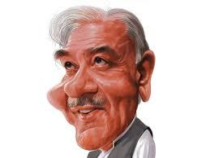

Speaking to reporters here along with Federal Minister for Communications Murad Saeed, he emphasized that in the past 10 years, Shahbaz and his family’s assets had grown by 70 percent and this came to light as a result of a NAB investigation into his assets in 2015.

He said Shahbaz Sharif’s son Salman Shahbaz's assets also grew by thousands of times, whereas a startling increase was witnessed in assets owned by his other son Hamza Shahbaz. He also accused Shahbaz Sharif of establishing 32 fake companies with the money brought back through the TT transactions.

He pointed out that three employees of Shahbaz's GMC Company were identified, who were found involved in running this multi-billion-rupee network, while its employees were working at the CM Secretariat on different posts.

He claimed one Nisar Gul, who was in the NAB custody, had admitted that this was a fake company through which they laundered Rs07 billion. Shahzad Akbar put 18 questions to the PML-N president and challenged him to respond to them.

He also called on the NAB to probe the Goo Nature Trading Company under which billions were money laundered through the fake TTs. He explained that the GMC emerged when investigation was carried out against the assets of Sharif family. He said through over 200 TTs, billions were ‘transferred’.

He said various measures were taken to show this ‘wealth’ as legal and even fake TTs were made, using names of poor citizens. He explained that corruption was carried out during Shahbaz's tenure as the Punjab chief minister.

Substantiating his presentation with the help of charts, he noted that their entire fortune had been built by funneling money from kickbacks into their personal accounts, before injecting them into their own companies to show as sales revenue.

## Fazal-ur-Rehman (Molana diesel)

**Fazal-ur-Rehman** is a hard-liner, right-wing [Pakistani](https://en.wikipedia.org/wiki/Pakistani) politician and current president of [Jamiat Ulema-e-Islam (F)](https://en.wikipedia.org/wiki/Jamiat_Ulema-e-Islam_(F)) (JUI-F) and Assembly of Islamic Scholars. Rehman was a member of the [National Assembly](https://en.wikipedia.org/wiki/National_Assembly_of_Pakistan) between 1988 and May 2018 and previously served as [Leader of the Opposition](https://en.wikipedia.org/wiki/Leader_of_the_Opposition_(Pakistan)) from 2004 to 2007.

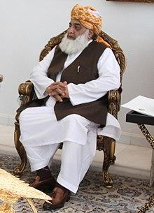

Jamiat Ulama-e-Islam-Ideological (JUI-I) alleged that Maulana Fazlur Rahman was protecting corrupt politicians and deceiving the nation in the garb of the religion.

The JUI-I KP chief Maulana Zubair while speaking at a press conference on Thursday alleged that the alliance of Maulana Fazal-ur-Rahman and former premier Mian Nawaz Sharif was aimed at protecting their corruption.

He said that the JUI-F chief was neither sincere with Islam nor Pakistan, adding that he knew only one thing that how to accumulate money. He alleged that Maulana Fazal in 2002 had been living in a mud-made house in Dera Ismail Khan, but now he is leading a lavish life with expensive bullet-proof vehicles and enjoying VIP protocol along with family members. He also asked Maulana Fazal to reveal his sources of income.

Maulana Zubair said that Maulana Fazal was a secularist leader, who, he said, was misguiding people by presenting himself the other. He alleged that former dictator Pervez Musharraf had bestowed Maulana Fazal with agriculture lands in D.I. Khan for supporting him in the passage of 17th Constitutional Amendment and the LFO, he maintained.

### Why Molana Diesel

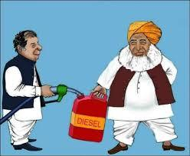

Its alleged that when he was a minister in Benazir Bhutto’s government between 1993 to 1996 as minister of petroleum, he took advantage of his position and smuggled diesel to Afghanistan. He is supposed to have made a lot of money by doing this. He sold the diesel at high prices and pocketed the money and brought a diesel crisis in Pakistan. Although it was never proven it is commonly believed to have happened.

## A CRITIQUE FROM THE LEADERSHIP AND STRATEGIC POINT OF VIEW:

### Flaws of Asif Ali Zardari

**Problem:** His leadership lacks faith because he was a corrupt leader people do not believe in his party.

**Solution:** A leader should be faithful because of him, his party nourishes.

**Problem:** Lack of Credibility

**Solution:** Although the leader has brought forth tremendous projects for the nation, their corruption cases makes them lose their credibility somehow.

**Problem:**

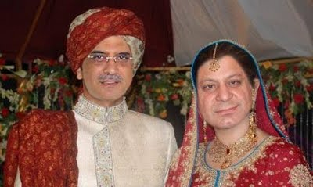

Dependent Decision making was another problem. The leader gives an image to be very much influenced by others in taking his decision rather than deciding on his own.

**Solution:** Take and own your decisions.

### Flaws of Mian Muhammad Nawaz Sharif

**Problem:** Lack of Credibility

**Solution:** Although the leader has brought forth tremendous projects for the nation, their corruption cases makes them lose their credibility somehow.

**Problem:**



Dependent Decision making was another problem. The leader gives an image to be very much influenced by others in taking his decision rather than deciding on his own.

**Solution:** Take and own your decisions.

### Flaws of Pervez Musharraf

**Problem:** He did not manage all the aspects which are going to affect his leadership.

**Solution:** A leader should manage all the possible scenarios which are going to affect him in future.

**Problem:** Lack of persuasion style

**Solution:** Persuasion is a major form of influence and without influence there is no effective leadership

### Flaws of Imran Khan:

**Problem:** The Leader uses a lot of junk words and foul language in his addresses while talking about his competitor politicians

**Solution:** Minimize Language Errors, Junk Words, and Vocalized Pauses.

**Problem:** Lack of Credibility

**Solution:** Although the leader has brought forth tremendous projects for the nation, their corruption cases makes them lose their credibility somehow.

**Problem:**

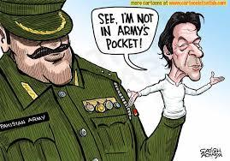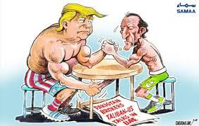

Dependent Decision making was another problem. The leader gives an image to be very much influenced by others in taking his decision rather than deciding on his own.

**Solution:** Take and own your decisions.

### Flaws of Shehbaz Sharif:

**Problem:**

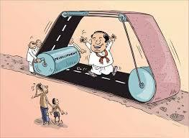

Shehbaz Sharif lacks consultation with others because he used to do some projects, which may not be the need of the hour in the eyes of many.

**Solution:** When the leader asks the group member to participate in

planning an activity. This is also a leadership **style participative**

The influence comes from the asking of group members for

their input and then in returning finding they are more apt to

buy in to what they are being asked to do.

**Problem:** Lack of Credibility

**Solution:** Although the leader has brought forth tremendous projects for the nation, their corruption cases makes them lose their credibility somehow.

**Problem:**

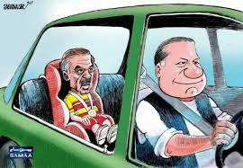

Dependent Decision making was another problem. The leader gives an image to be very much influenced by others in taking his decision rather than deciding on his own.

**Solution:** Take and own your decisions.

### Flaws of Molana Fazal Ur Rehman:

**Problem:**

Absence of Backup with conclusion data, whenever Molana used to perform his duties as a leader what he said was not usually backed up with statistical facts.

**Solution:**

* Use of factual data to enhance persuasion.
* You can collect data or published sources also provide convincing data for arguments. Newspapers, business magazines and the Internet.

**Problem:** Lack of persuasion style

**Solution:** Persuasion is a major form of influence and without influence there is no effective leadership

**Problem:** He had an avoiding attitude towards conflicts and clashes.

**Solution:**

* **Competitive Style:** Desire to achieve one’s own goals at the expense of the other party, or to dominate.
* **Accommodative Style:** Favors appeasement, or satisfying the other’s concerns without taking care of one’s own.
* **Sharing Style:** Prefers moderate but incomplete satisfaction for both parties, resulting in a compromise.
* **Collaborative Style:** reflects a desire to fully satisfy the desires of both parties.

**Problem:** Lacked an Influence over his audience

**Solution:**

* Leading by Example and Respect
* Using Rational Persuasion
* Apprising the Target
* Making a Personal Appeal
* Developing a Reputation as a Subject Matter Expert
* Exchanging Favors and Bargaining
* Legitimating a Request
* Making an Inspirational Appeal, Being Charming, and
* Emotional Display
* Consultation with Others
* Forming Coalitions
* Being a Team Player

**Problem:** Lack of Credibility

**Solution:** Although the leader has brought forth tremendous projects for the nation, their corruption cases makes them lose their credibility somehow.

**Problem:**

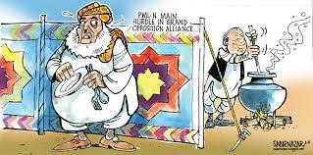

Dependent Decision-making was another problem. The leader gives an image to be very much influenced by others in taking his decision rather than deciding on his own.

**Solution:** Take and own your decisions.

# CORRUPTION AND ITS IMPACT ON SOCIETY

Abstract. Good Governance flourish in a necessarily corruption free situation. Pakistan is unfortunately way down on the ladder on this account. Corruption of all magnitudes mega, moderate and petty permeates all tiers of governance and all segments of the society public, private, political, judicial, commercial and even religions. Paradoxically corruption acts as the balancing market mechanism here in a vastly unregulated administrative paradigm. There exists surreal economic rationale for this give and take at the individual level but economic cost to the society is stupendous. Corruption severely impacts the life of the citizens through less returns on resource use and adds manifold to their cost of living. Genesis of corruption in Pakistan can be traced to the mega events of 1940s to 1990s and even the current decade. Serious attempts at accountability originating in mid 1990s and fortified on the turn of the century farcically turned into tools of political patronage or victimization. For the last two years there is a practically a legal vacuum at the national level. A host of measures are needed to eradicate this menace. The awareness in the general public and emergence of a strong civil society, vociferous media and a newly independent judiciary all by themselves stand as a guarantee to the success of any future program of accountability.

## INTRODUCTION:

Corruption is a much-practiced evil from which originates countless misdemeanors. It can rightly be asserted that corruption acts like a “wellhead” for other malpractices which in aftermath, destroys the fabric of society. Unfortunately, Pakistan is replete with these all-too-often corrupt practices. M.Ali Jinnah, our founder, was desirous of foundering a corruption-free Pakistan where law would prevail over all. However, his dream was thrown to wolves highhandedly by power-brokers and Pakistan was acutely exposed to chronic waves of corruption. Subsequently, this social evil helped hold a defective system in place which has been paralyzing the existence of merit since independence.

At present, tales of corruption in Pakistan are stretching as far as eye can notice. If somebody happens to unscrew our social container, he will find corruption to the brim.

Of all reasons, the most ingrained one is poverty. In Pakistan, 29.5% people are living beneath the poverty line wherein collateral damages caused by this poverty are locking population in a vicious cycle of unemployment and unfair means of livelihood. In words of Peter Eigen, Transparency International Chairman, “Corruption is a major cause of poverty as well as a barrier to overcoming it”. These two distasteful words- corruption and poverty- reciprocate each other in kind. Everywhere the poor of a society can be readied easily to accept or give any purposeful sop or tip. Reason behind this fact lies in a sentence composed by Arundhati Roy in her novel that, “need is a warehouse that can accumulate a considerable amount of cruelty”. So, it is fair to admit that a corrupt society compels even an honest man to engage himself in irregularities- a concept explained by Plato as ‘honest lies’. At short, cause-and-effect relationship of corruption and poverty is exceedingly virulent for the skeleton of a polity.

Second reason behind rampant corruption in Pakistan is deep-seated kinship system. In order to keep loyalties intact down the kinship lineages, our politicians sucker their relatives and electorates through jobberies and patronage-oriented politics. This fact provides us a reason to believe that kinship-based system in Pakistan throttles merit and puts muscles in the concept of nepotism and cronyism. Although Anatol Lieven, author of Pakistan ‘a hard country’, has declared this kinship system a “safety value” for problem-ridden society of Pakistan; yet this can’t be institutionalized due to its unseen demerits. Kinship system is a compromise and provides only a make-do shelter for needy people. As long as kinship system is in effect, Pakistan can’t be jumpstarted unto way of progress and transparency.

Corruption trickles down from the top-tier of a system in general and from bureaucracy in particular. Unless bureaucracy subscribes itself to self-accountability, corruption from “lumpen” of a society can never be wiped out. Furthermore, bureaucracy creates a bridge between government and common masses. If that bridge is rickety and unstable, system overall will be prone to illegitimate practices like corruption and terrorism. In Pakistan, bureaucracy is full of defects. It needs to be reformed on the pattern of what Margaret Thatcher did to bureaucracy of Great Britain. She introduced efficiency unit headed by a senior bureaucrat in 1982 whose duty was to make bureaucracy responsive, efficient and well-managed. Henceforth, reforms in bureaucracy are much-needed and ought to be launched without any delay.

Corruption is more a moral issue than a legal one. It is high time that every citizen should begin to consider it a plague and make it extinct forever.

Corruption defined as misuse of entrusted power for private benefit is unfortunately endemic in Pakistan. No structure, no tier and no office of public sector is immune from it. Its spread is enormous. It has reached every organ of state — beyond executive it has put its claws on judiciary and legislature even. It would be no exaggeration to say that the whole body of the state of Pakistan is suffering from this malaise and wailing under its dead weight. So enormous is its incidence that Pakistan is ranked 139th in the Committee of nations on the scale of corruption free governance. This ranking is not at all enviable or acceptable.

TABLE 1

Transparency International; Corruption Perception Index Pakistan Score and Ranking

|  |  |  |  |
| --- | --- | --- | --- |
| Year | Pakistan Rank/Score | Pak Most Corrupt Rank | No. of Countries Ranked |
| 2019 | 139/2.4 | 42 | 180 |
| 2018 | 134/2.5 | 47 | 180 |
| 2017 | 138/2.4 | 42 | 179 |
| 2016 | 142/2.2 | 20 | 163 |
| 2015 | 144/2.1 | 16 | 159 |
| 2004 | 129/2.1 | 19 | 147 |
| 2003 | 92/2.5 | 42 | 133 |
| 2002 | 77/2.6 | 26 | 102 |
| 2001 | 79/2.3 | 13 | 91 |
| 2000 | N/A | N/A | 90 |
| 1999 | 87/2.2 | 13 | 99 |
| 1998 | 71/2.7 | 15 | 85 |
| 1997 | 48/2.53 | 5 | 52 |
| 1996 | 53/1 | 2 | 54 |

*Source:* [*http://www.transparency.org.pk/.../CPI2009/CPI20*](http://www.transparency.org.pk/.../CPI2009/CPI20) *2009 Press Release November 2009.doc*

“Corruption manifests itself in various forms in Pakistan, including widespread financial and political corruption, nepotism, and misuse of power. Both petty and grand corruptions are prevalent in the country” .Corruption clouds almost all tiers of government; it is all pervasive and deeply entrenched. “The level of corruption in the society ultimately depends on the values and morals of that society”. Over the period acceptability of corruption has rather increased in the society and there is little evidence that people feel guilty about their own role in corruption. The scale of corruption is highest in development projects and procurement (including defense and public sector corporations) and the bank loan write offs. Whereas mega corruption is mainly in development projects, bank loans and procurements which rocks the foundation of the economy, the common man is more interested in the petty and middle level corruption that he encounters in the daily dealings in the government offices.

According to one estimate the loss made to the national exchequer is over Rs. 200 billion per annum. This loss is caused collectively by all the government departments but the most prominent amongst them as per the Perception Survey carried out by Transparency International Pakistan are:

* Power Sector
* Tax and Customs
* Police and Law Enforcement
* Judiciary and Legal Profession
* Health and Education
* Land Administration

The main features of the Pakistan National Corruption Perception Survey 2009 and ranking in 2006 and 2002 NCPS are detailed below:

TABLE 2

Pakistan National Corruption Perception Survey (Institutions)

|  |  |  |  |
| --- | --- | --- | --- |
| S. No. | Years | | |
| 2019 | 2016 | 2012 |
| 1 | Police | Police | Police |
| 2 | Power | Power | Power |
| 3 | Health | Judiciary | Taxation |
| 4 | Land | Land | Judiciary |
| 5 | Education | Taxation | Custom |
| 6 | Taxation | Custom | Health |
| 7 | Judiciary | Health | Land |
| 8 | Local Govt. | Education | Education |
| 9 | Custom | Railway | Railway |
| 10 | Tendering | Bank | Bank |

In the opinion of 5,200 respondents the ranking of ten government departments are (Rank 1 being the most corrupt and 10 being the least corrupt).

## GENESIS OF CORRUPTION IN PAKISTAN

The roots of corruption in Pakistan date back to the colonial period when the Britishers rewarded lands and titles to those who were their loyalists leading to nepotism and corruption (Awan, 2004:19). Two major crises played a fundamental role in the genesis of corruption in this part of the world; the spiral in the defense related purchases during and after the World War II and allotment of evacuee property after the partition of Indian subcontinent (UNDP, 2002:11). This was followed by industrial and trade licensing and patronage schemes like bonus voucher and route permits in 1950s and 1960s. The nationalization policy of the 1970s created new opportunities for corruption and gave birth to a new breed of corrupt government officers. The decade of 1980s witnessed the surge of corruption in religious and business circles.

The causes of this malady are to be found in the socio-cultural and political matrix of the Pakistani society which presently is faced with a gradual loss of value system and even identity. It is extremely difficult to ascertain the exact causes and their degree in matters pertaining to human psyche and temperament, yet according to a Perception Survey carried out by Transparency International Pakistan in year 2004, the following causes have been determined as the major contributors towards corruption and their estimated degree in percentage terms has also been indicated in Table 3.

TABLE 3

TI – Survey on Causes of Corruption — Mega and Petty

|  |  |
| --- | --- |
| Lack of Accountability | 31.68% |
| Low Salaries | 16.54% |
| Monopoly of Power | 16.43% |
| Discretionary Power | 12.61% |
| Lack of Transparency | 9.97% |
| Power of influential people | 4.59% |
| Red Tapism | 4.28% |
| Others | 4.9% |

Source: NACS – NAB, Government of Pakistan.

Petty corruption is mainly for getting access to public services or to bypass or twist the laws and the rules. Middle and grand corruption pertain to public contracting and procurement.

In a pre-dominantly capitalist economic order and the increasing adherence to principles of free market, rise in corruption and speed money clearly makes an economic sense. Some of the so-called economic reasons can be enumerated as under:

1. Bribe serves as an incentive for the government servants.
2. It is a kind of price that equates supply and demand in every field and office.
3. Paradoxically in many cases it reduces transaction cost for the petitioners/applicants by saving their time and miscellaneous costs on frequent visits.
4. In case of getting contracts, certain concessions or exemptions and buying shares and parcels of privatized firms the rate of return on every unit of bribe is phenomenal.
5. Similarly, net gains through bribing the voters, score off the cost of the venture.
6. Payments for getting favorable decisions in civil suits may be only a fraction of the value of the suit. Similarly securing one’s liberty in criminal cases involving huge sums has a lot of intrinsic value.
7. “High inequality can lead to greater incentives for corruption”

This is however only the commercial side of it. In the real economic sense, it is a net loss to the society in terms of reduced availability of funds for development, artificial increase in cost per unit of resources use and increased impoverishment of the weaker sections of the society. “Corruption and poor governance limit economic growth and retard the development of a healthy private sector” (UNDP, 1997).

Whatever the causes or the rationale behind this massive trend of corruption whether justified or not the fact remains that it has deeply impacted the economy, the society, and the country. Some important areas affected by it are discussed as under:

The world economic forum’s Global Competitiveness Report (2007-08) identifies corruption as the 3rd greatest problem for companies doing business in Pakistan after government bureaucracy and poor infrastructure It is therefore a direct impediment in the way of the Direct Foreign Investment (DFI) which is so badly needed to generate economic activity, create employment, and support the dwindling foreign exchange reserves.

1. With an effective check on corruption national exchequer can easily gain nearly double of the annual allocations earmarked under Kerry Lugar Bill carrying strikingly harsh conditions for national sovereignty and autonomy.
2. The cycle is really vicious rampant corruption in tax and custom and excise collection and WAPDA dues and costly public sector purchases, and inefficient major public sector entities like PIA, Railway, Steel Mill etc. cause a major deficit for the government every year in term of resource generation and expenditure that makes the government borrow from IMF and other foreign and domestic resources which through increased debt repayments broadens the gap and compels the government to increase the price of the utilities like electricity, gas, CNG and petroleum. That takes a heavy toll from the people of Pakistan. Resultantly corruption which is done at far away and much higher places from the common citizens has a direct and deep impact on their lives. Thus, act of corruption, whether direct or indirect, close or remote is not innocuous for common man.
3. The country has lost many years of development effort because of eating up of development funds at a very large scale and because of overcharging for almost every item of work.
4. Other than the government offices and public sector, corruption has thoroughly permeated the political arenas. Party tickets are openly bought and sold and so does the transaction flourish for hunting or hounding the voters. This has resulted in the dominance of political scene by the drug barons, black marketers, hoarders and speculators who not only have in many cases snatched away the true representative character from the democratic process in the country but who make good their investment in the election process through massive corruption while in power and add to the miseries and the cost of living of the common man.
5. Still worse is its impact on religious circles who sell fake degrees to the needy politicians with impunity, show fake entries of students to get more Zakat money and sell religion edicts on need basis. At times it appears that the whole structure has been soiled and has replaced scholarship as it is becoming increasingly difficult to find a genuine religious scholar from any quarters.
6. Rampant trends of corruption have also badly affected the business ethics in the country which is devoid of any egalitarianism. Hood winking the regulators, stock piling, hoarding, and black marketing are the order of the day and individual business man, business firms, business groups and sometimes a whole industry is found pegged in these malpractices.
7. And when corruption affects the institution of the last resort that is the judiciary the country loses its track and direction. Absence of a fair judicial system does not affect the individual litigant alone it affects the whole economy where domestic and foreign investments shy away for fear of usurpation and misappropriation.
8. The worst of all is a breakdown of law and order because of pervasive corruption in police and lower judiciary. The influential, the wealthy and the mighty have a fair chance of getting away with whatever they do if they pay the right price at the right stage. This had led to increased incidence of crimes of all nature and at all levels.
9. In short, the unbridled corruption has negatively impacted all spheres of activity in the country and the whole society has suffered serious blows to its social fabric and working environment.

# 

# REMEDIES FOR COVID-19

* The federal government has prepared draft for Rs7,570 billion federal budget 2010-21. The draft will be finalized in the first ten days of June and will be sent to federal cabinet for approval. The budget will be presented in the parliament on June 12.According to sources in the Ministry of Finance, [23] Rs1,000 billion is also expected to be allocated for dealing with coronavirus pandemic and for providing relief to the business community.
* Public should be aware enough of all the outcomes they are facing or that they should keep in their mind that the whole world is facing economic loss due to COVID-19. If they want to lift lockdown as soon as possible they should maintain integrity with all the SOP provided to them.
* HEC should make proper guidelines for institutes for carrying out online learning mechanism. Internet facility should be made possible for all the students by all means.
* Proper slots for people should be made in halls, super markets, grocery stores. Mosques. And all other public places so that violation of rules decreases.

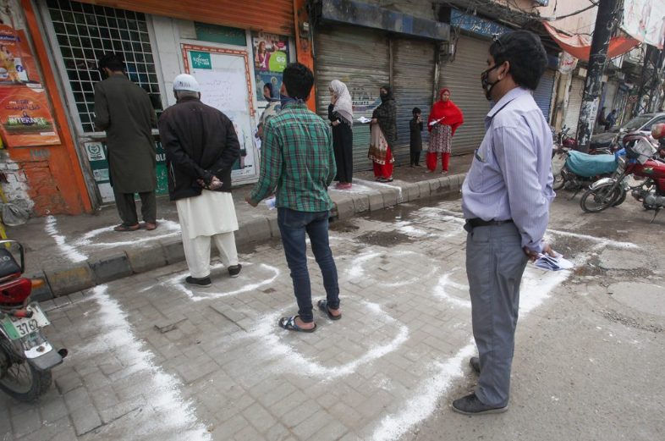

* Compulsion must be made for wearing masks and gloves in all the public gatherings or places else fine will be charged. [24]
* Isolation wards must be increased so that infected people no longer affect the people and, in this way, total number of cases can be decreased per day.
* Instead of establishing taxes on imports and exports, Money should be spent in buying extra ventilators for patients so that they no longer suffocate themselves to death.
* Kits to doctors and other co-workers must be provided, because they are real heroes who are dealing with COVID patients. Doctors, nurses, pharmacists and lab technicians are priceless assets of the country against deadly viruses.
* Social gatherings must not be done unless it is made sure that no person is infected with COVID-19
* Proper hygiene and cleanliness must be maintained in order to keep themselves preventive towards this virus.

# Steps to Curtail Corruption in Pakistan

**“What kind of Pakistan do we want for our children?”**

A civil society activist asked recently. “It has to be an inclusive state which is fair, honest and open to everyone.” The promise of this future lies in an entire generation standing-up for accountability and holding those in power responsible for their actions. This is not easy, of course, but it is essential- and it can be done in Pakistan as it can in other countries in South Asia and beyond. Here are some ideas.

First, young people must lead change. The median age in Pakistan is now 22 years old, with 63% of the population under the age of 25. Young Pakistanis are globalized, energized and full of ideas. They are less entrenched in patronage networks, more willing to question existing realities and better connected than ever before. But this doesn’t mean that suddenly everything is going to be different. They need support over time to sustain the change they want to see. Their creativity tends to exist in pockets and despite some recent mobilization politically, is largely delinked from policymaking. We need to build an ecosystem to support these young change-makers - mentorship, opportunities, collaborative spaces and communities - and to jointly maximize their efforts. Organizations like Seed Ventures and incubators like Plan 9 are doing it for entrepreneurs; we are doing the same for “accountapreneurs”.

Second, this is about more than creating organizations and enforcing rules. At the national level, Pakistan now has around half a dozen anti-corruption bodies, 10 different ombudsmen and a plethora of other agencies tasked in one way or another with accountability. But organizations set up to fight graft will not work if they are not aligned with the relationships, cultural norms and incentives that shape behaviors. If a dynamic of corruption is entrenched, it is too difficult - and arguably illogical - for brave individuals to stand-up alone and try and change the system. They need peers everywhere who will support them. This means Pakistan must think now about a long-term process to shift mindsets through investing heavily in civic education, leadership programs and values-based networks. Organizations like the Atlantic Council and the British Council are doing a great job, but there is much more to do.

Third, creativity is essential to fighting corruption because many stakeholders in the existing system are resistant to change. For too long - driven by an aid system that measures successes based on numbers of outputs and dollars spent - the response to corruption and patronage has been training and seminars. But all-day workshops with free lunches are not a substitute for real change. If we want to bring young people into this process effectively, we have to meet them where they are, not where we want them to be. This means using tools and platforms they enjoy - like the arts, media, film and technology - and deploying them in interactive ways. From creative visual arts with organizations like Morongo Films, to ICT collaborative like the Technology for the People Initiative, the potential intersections of innovation and integrity in Pakistan are easy to find.

Fourth, bring in the private sector as a key driver of change. Despite significant challenges, Pakistan’s business community is world class, with some incredible, values-based leaders who operate at the highest levels of global commerce. They lead companies that are thinking well beyond the bottom-line and draw on Pakistan’s rich culture of generous philanthropy. They know that integrity is good for business - ethical companies have higher valuations, lower costs and less risk. This energy can be harnessed to create a level playing field for economic development and collaborative efforts to shift accountability dynamics. Businesses came together to play a key role in the passage of the important Drug Regulatory Authority of Pakistan (DRAP) Bill of 2012 for example - which cleaned up the pharmaceutical industry. Businesses are driving the Open Government Partnership efforts in Pakistan and collaborative like Open Lahore and CIPE are working to improve standards of transparency. We must support them further.

Finally, accountability requires a positive narrative that Pakistanis can buy in to and mobilize behind. Pointing fingers and shouting loudly at law-breakers is an easy way to vent some frustration - and there is no doubt that these people should be penalized. But when justice is not served the perception of helplessness is reinforced and momentum in the process of accountability building is lost. Instead, let’s make sure we celebrate the heroes, build on areas where success is clear and work to support those who are doing the right things - “naming and faming” is a useful substitute for “naming and shaming”. Last year, for example, at the Accountability Lab organized a television and social media campaign around the world called Integrity Idol - which rewarded honesty in government and galvanized national conversations about what it means to be an accountable civil servant. This year they’ll run the competition in Pakistan too.

Building accountability is not about overcoming weaknesses - it is about a strengths-based approach that draws upon human, institutional, cultural and economic assets. Short-term fixes and anti-corruption tools might prove effective in battling graft in isolated ways. But if Pakistan - and other countries - are to truly create fair and open societies for everyone, it is going to take a much larger, generational process to build accountability. The time to start is now.

## EFFORTS TO CURB CORRUPTION

Corruption can be curbed or limited through the presence of a monitor or a monitoring process .Although provincial Anti-Corruption Establishment were put in place in 1960s, and a Federal Investigation Agency was constituted to fight corruption in public sector, it turned out that anti-corruption arm of the police is the most corrupt. Slowly and gradually the tendency for corruption gained momentum and got the better of governmental efforts.

The 1st serious attempt to fight corruption at national level was witnessed during the caretaker period after the dismissal of 2nd Benazir government in November 1996 when President Farooq Leghari established Ehtsab Commission headed by a retired senior judge. The effort was intensified by the next government, *i.e.* the 2nd Nawaz government in 1997 through the aegis of Ehtsab Bureau headed by Mr. Saif ur Rehman. The exercise was however taken as one sided and led to the erosion of moral authority for so pious an exercise.

The army government of 1999 started accountability with a lot of fanfare. It established National Accountability Bureau (NAB) with necessary investigation and judicial structures. It announced National Anti-Corruption Strategy (NACS). NACS was a three-pronged strategy, *viz.*

1. Prevention
2. Awareness
3. Enforcement

The National Accountability Strategy announced in 2002 has been in limbo ever since its inception as it failed to gain the required political patronage/acceptance within the NAB establishment, due to lack of support from the donors, and for poor communication and exposure with the general public.

Some new systems were introduced for improving the public sector procurement and a whole new standard operating procedure (SOP) was laid down in the form of a manual by the newly constituted “Public Procurement Regulatory Authority” (PPRA) which over saw all purchases beyond the value of a Rs. 50 million.

The Auditor General’s office introduced a new project titled “Project for Improvement in Reporting and Auditing” (PIFRA) with a view to adopt modern formats and technique for financial reporting and auditing.

On the side of judiciary and police it started a $ 350 million access to Justice Program for capacity building and knowledge based and improved working environment.

Access to Justice Program aimed at the following:

1. Improving predictability and consistency between fiscal and human resources and the mandates of reformed judicial and public institutions at the federal, provincial and local level.
2. Ensuring greater transparency and accountability in the performance of the judiciary, the police and administration justice institutions.
3. Providing a legal basis for judicial, policy and administration reforms.
4. Improving the efficiency time lines and effectiveness in judicial and police services.
5. Supporting greater equality and accessibility in justice services for the vulnerable poor.

*Source:* [*http://friendsofpakistan.net/?tag=barometer-of-corruption.*](http://friendsofpakistan.net/?tag=barometer-of-corruption)

The new Police Order, 2002, re-organized the force through separation of force into various branches, bureaus, sections and divisions. The goal was to improve the efficiency, it is to be seen whether it has achieved its objectives or resulted in increased corruption through a wider spread of functions and lack of coordination.

Similarly, it is to be observed carefully whether the changes brought in the land administration at sub-divisional, district and divisional level have improved efficiency, transparency and fairness or it has achieved the reverse results. If public perception is any yardstick it is clearly in the negative direction.

The accountability effort was phenomenal with a thumping response from the public and a loud and clear message for the delinquents. But half of it evaporated due to political exigencies of election 2002 and the remaining half became thin air with the promulgation of National Reconciliation Order (NRO) in October 2007.

NRO was the worst law ever made in human history to formalize and legalize mega corruption. There was a significant back sliding in the accountability effort after the announcement of this ordinance. Accountability efforts which had started at a very promising note and with a telling effect especially with the establishment of NAB received set back close to the general election 2002 when the accountability structure was used for arm twisting of the politicians to rope them in for a new Kings Party. NRO was the last nail in coffin.

There has been a great void over the last over 2 years, *i.e.* between the promulgation of NRO in October 2007 and its annulment by the Supreme Court of Pakistan in December 2009. The whole accountability structure was diluted and was rather close to liquidation in that period.

The present government has preferred to let the accountability system remain suspended in the air and practically in the two years of the present democratically elected government there has not been a single major case registered or instituted by the government on its own.

Now there is big void, an immensurable vacuum, with actually no accountability law in force at the national level.

Along the way, however, there has been a significant development in the shape of the emergence of free press and media, which is very promising for the fight against corruption.

# CONCLUSION AND RECOMMENDATIONS

Corruption is one of most chronic issues all over world especially in the third world countries like Pakistan where it has routed down in government institutions enough that cannot be eliminated easily following the stakes of powerful bureaucrats and corrupt politicians.

Corruption has spoiled Pakistan completely and is resulting in increase in poverty, unemployment, hunger and is tarnished the image of the country by bringing immense miseries to its people. Corruption has been deep routed in all levels either private or government from top to bottom and anti-corruption institutions have unfavorably failed to address this or even reduce the ongoing dishonesty and frauds. There are many top politicians who have been reportedly involved in this misconduct that are concerned with their stakes only without thinking about the public.

We can find two vast concerns or issues in present Pakistan that are expanding like epidemics(corruption and terrorism) which have reinforced their germs in every cells of our society.

There are numerous indirect corruption charges from social media and electronic media present but no ruling authority is ready to investigate the corrupt persons for these illegal and dishonest concerns like illegal Sui-Gas and electricity supply, illegal possession of land and so on. Murder of merit and Justice, political nepotism and selling of government jobs by ‘corrupt ruling politicians’, hundreds of thousands of skilled and educated youth are deprived of deserving jobs.

It is the responsibility of every individuals to work jointly with the government institutions to make Pakistan a corruption-free country. Corruption will not prevail in the society until deserving peoples are given their rights. And this isn’t the Pakistan which our forbearers dreamt for.

“Poor governance leads to, and encourages and breeds, corruption in a number of ways, for instance through bribery and extortion, nepotism and fraud and embezzlement, It reduces the efficiency on which an economy depends, and by increasing the cost of investment, lowers the potential return. It also reduces the government’s resources and hence its capacity for investment. Common to other South Asian countries, corruption in Pakistan is unique because it occurs up stream, it has wings which encourage flight of capital rather than wheel which encourage reinvestment and it often rewards rather than punishes as the legal processes to fight corruption are weak in themselves and the lower judiciary is amenable to letting off the accused if the ‘price is right”

“Corruption is not a problem that can be attacked in isolation. It is not sufficient for the criminal law to search for bad apples and punish them. Of course, the state may need to establish credibility by punishing highly visible corrupt officials, but the goal of such prosecutions is to attract notice and public support, not solve the underlying problem. Anticorruption laws can only provide a background for more important structural reforms”

For almost all the reforms introduced by the Musharraf government in governmental and administration fields the basic assumption was that the society was sufficiently educated and hence eager and ready to change. The assumption proved wrong and rocked the whole foundation of the reforms agenda as the society proved to be ready for grabbing new opportunities but not to change its work ethics.

If this society is to be saved and the country has to shake off the tag of a failing or failed state, urgent and stringent measures need to be taken. Some of which are recommended as under:

1. Judgment of the Supreme Court against NRO be implanted in letter and spirit.
2. Accountability from the top be started.
3. A national anti-corruption commission be set up as an independent watchdog.
4. End unnecessary or archaic discretionary laws.
5. Ensure time bound actions in offices.
6. Use independent private sector auditors.
7. Involve people in diagnosing corrupt systems.
8. Advocate that all ‘illegal’ money and property transactions in industrialized countries are treated at par with drug money.
9. The problem of corruption is quite severe at the lower judiciary and a system of alternative dispute resolution needs to be worked out urgently.
10. Require public officials to declare their assets.
11. Community participation especially of students be ensured.
12. Creating awareness particularly about the adverse impact on every one’s life be highlighted to mobilize public against corruption. “The evolution of a public opinion, which must follow the spread of education, which rejects corruption either because it is morally wrong or because it is scientifically inefficient, or both” (Wraith and Simpkins, 1963:208).
13. Poverty alleviation and economic reforms (Hussain and Hussain, 1993:161).

The remodeling and over haul of higher judiciary and its clearance from PCO judges through a protracted and participatory process has brought a lot of awakening amongst the public along with the formation of a formidable civil society which has manifold increased the chance of a real purge in the system.

# 

# REFERENCES

[x](C:\\Users\\HP\\Downloads\\xx)

|  |  |
| --- | --- |
| [[1]](C:\\Users\\HP\\Downloads\\xx) | [(2020, Junw) Total Record Of Covid Cases In Pakistan. [Online]. HYPERLINK "https://coronavirus.app/tracking/pakistan" https://coronavirus.app/tracking/pakistan](C:\\Users\\HP\\Downloads\\xx) |
| [[2]](C:\\Users\\HP\\Downloads\\xx) | [Y., Zhao, Y., Liu, J., He, X., Wang, B., Fu, S., Yan, J., Niu, J., Zhou, J., Luo, B Ma. (2020) Effects of temperature variation and humidity on the death of COVID-19 in Wuhan, China. [Online]. HYPERLINK "https://doi.org/10.1016/j.scitotenv.2020.138226" https://doi.org/10.1016/j.scitotenv.2020.138226](C:\\Users\\HP\\Downloads\\xx) |
| [[3]](C:\\Users\\HP\\Downloads\\xx) | [E.K., Wilson-Genderson, M., Heid, A.R., Pruchno, R.A Cromley, "Spatial association of multiple chronic conditions Among other Abdults," no. 2018, p. 11, 2018.](C:\\Users\\HP\\Downloads\\xx) |
| [[4]](C:\\Users\\HP\\Downloads\\xx) | [(2020, March) World Health Organization. [Online]. HYPERLINK "Critical%20Preparedness,%20Readiness%20and%20Response%20Actions%20for%20COVID-19-7%20March%202020" Critical Preparedness, Readiness and Response Actions for COVID-19-7 March 2020](C:\\Users\\HP\\Downloads\\xx) |
| [[5]](C:\\Users\\HP\\Downloads\\xx) | [PhD Rebecca K Webster, PhD Samantha K Brooks. (2020, February) The psychological impact of quarantine and how to reduce it: rapid review of the evidence. [Online]. HYPERLINK "https://www.thelancet.com/journals/lancet/article/PIIS0140-6736(20)30460-8/fulltext" \l "%20" https://www.thelancet.com/journals/lancet/article/PIIS0140-6736(20)30460-8/fulltext#%20](C:\\Users\\HP\\Downloads\\xx) |
| [[6]](C:\\Users\\HP\\Downloads\\xx) | [Make it. (2020, april) Virtual reality videos can help you feel calm and connected during coronavirus quarantine. [Online]. HYPERLINK "https://www.cnbc.com/2020/04/25/study-vr-helps-you-feel-calm-and-connected-amid-covid-19-quarantine.html" https://www.cnbc.com/2020/04/25/study-vr-helps-you-feel-calm-and-connected-amid-covid-19-quarantine.html](C:\\Users\\HP\\Downloads\\xx) |
| [[7]](C:\\Users\\HP\\Downloads\\xx) | [(2020, 4 June) Covid-19: Pakistan likely to incur Rs1.3tr economic loss. [Online]. HYPERLINK "https://www.thenews.com.pk/print/660747-covid-19-pakistan-likely-to-incur-rs1-3tr-economic-loss" https://www.thenews.com.pk/print/660747-covid-19-pakistan-likely-to-incur-rs1-3tr-economic-loss](C:\\Users\\HP\\Downloads\\xx) |
| [[8]](C:\\Users\\HP\\Downloads\\xx) | [Peterson and Arun, Thankom Ozili, "pillover of COVID-19: impact on the Global Economy,"](C:\\Users\\HP\\Downloads\\xx) *[SSRN Electronic Journal](C:\\Users\\HP\\Downloads\\xx)*[, no. 0.2139/ssrn.3562570, March 2020.](C:\\Users\\HP\\Downloads\\xx) |
| [[9]](C:\\Users\\HP\\Downloads\\xx) | [(2020, March) Covid patients attended prayers in Pakistan. [Online]. HYPERLINK "https://www.geo.tv/latest/278852-gazas-two-confirmed-coronavirus-patients-attended-tablighi-ijtema-in-pakistan" https://www.geo.tv/latest/278852-gazas-two-confirmed-coronavirus-patients-attended-tablighi-ijtema-in-pakistan](C:\\Users\\HP\\Downloads\\xx) |
| [[10]](C:\\Users\\HP\\Downloads\\xx) | [(2020, april) Army called out for help in amidst Coronavirus Outbreak. [Online]. HYPERLINK "https://www.geo.tv/latest/278812-government-calls-in-pakistan-army-troops-amid-coronavirus-outbreak" https://www.geo.tv/latest/278812-government-calls-in-pakistan-army-troops-amid-coronavirus-outbreak](C:\\Users\\HP\\Downloads\\xx) |
| [[11]](C:\\Users\\HP\\Downloads\\xx) | [UNESCO. (2020, March). Half of World’s Student Population Not Attending School: UNESCO. [Online]. HYPERLINK ".%20https://en.unesco.org/news/half-worlds-student-populationnot-attending-school-unesco-launches-global-coalition-accelerate" . https://en.unesco.org/news/half-worlds-student-populationnot-attending-school-unesco-launches-global-coalition-accelerate](C:\\Users\\HP\\Downloads\\xx) |
| [[12]](C:\\Users\\HP\\Downloads\\xx) | [Rakesh Kochhar and Amanda Barroso. (2020, March 27) Young workers likely to be hard hit as COVID-19 strikes a blow to restaurants and other service sector jobs. [Online]. HYPERLINK "https://www.pewresearch.org/fact-tank/2020/03/27/young-workers-likely-to-be-hard-hit-as-covid-19-strikes-a-blow-to-restaurants-and-other-service-sector-jobs/" https://www.pewresearch.org/fact-tank/2020/03/27/young-workers-likely-to-be-hard-hit-as-covid-19-strikes-a-blow-to-restaurants-and-other-service-sector-jobs/](C:\\Users\\HP\\Downloads\\xx) |
| [[13]](C:\\Users\\HP\\Downloads\\xx) | [(2020, April) Hunger strikes. [Online]. HYPERLINK "https://www.rferl.org/a/coronavirus-pakistan-delicate-balance-lockdown-economy-resistance/30547870.html" https://www.rferl.org/a/coronavirus-pakistan-delicate-balance-lockdown-economy-resistance/30547870.html](C:\\Users\\HP\\Downloads\\xx) |
| [[14]](C:\\Users\\HP\\Downloads\\xx) | [Geo News. (2020, March) Coronavirus updates, March 24: Latest news on the coronavirus pandemic from Pakistan and around the world. [Online]. HYPERLINK "https://www.geo.tv/latest/278800-coronavirus-updates-march-24-latest-news-on-the-coronavirus-pandemic-from-pakistan-and-around-the-world" https://www.geo.tv/latest/278800-coronavirus-updates-march-24-latest-news-on-the-coronavirus-pandemic-from-pakistan-and-around-the-world](C:\\Users\\HP\\Downloads\\xx) |
| [[15]](C:\\Users\\HP\\Downloads\\xx) | [Patients attended prayees. [Online]. HYPERLINK "https://www.geo.tv/latest/278852-gazas-two-confirmed-coronavirus-patients-attended-tablighi-ijtema-in-pakistan" https://www.geo.tv/latest/278852-gazas-two-confirmed-coronavirus-patients-attended-tablighi-ijtema-in-pakistan](C:\\Users\\HP\\Downloads\\xx) |

[x](C:\\Users\\HP\\Downloads\\xx)

Awan, Malik Khuda Bakhsh (2004), *Anti-Corruption: Strategies in Pakistan*.

Lahore: Book Biz.

Chene, Marie (2008), Overview of corruption in Pakistan. Retrieved May 17, 2010, from [http://www.u4.no/helpdesk/helpdesk/query.cfm?id=174.](http://www.u4.no/helpdesk/helpdesk/query.cfm?id=174)

Hussain, Mushahid and Akmal Hussain (1993), *Pakistan*: *Problems of Governance*.

Lahore: Vanguard Books Pvt. Ltd.

Ismail, Zafar H. and Sehar Rizvi, Some issues of governance in Pakistan. Retrieved on May 17, 2010 from [http://www.spdc.org.pk/pubs/cp/cp39.pdf.](http://www.spdc.org.pk/pubs/cp/cp39.pdf)

Khan, Masood, Niaz A. Shah Kakakhel and Melvin J. Dubnick (2004), *Prosecuting Corruption*: *The Case of Pakistan*. Ethics Forum, American Society for Public Administration, 26-27 March, 2004.

Rose-Ackerman, Susan (1999), *Corruption and Government.* UK: Cambridge University Press.

Sala-i-Martin, Xavier and Michael E. Porter (2008), The global competitiveness report 2007-2008. Retrieved May 17, 2010 from http://www.gcr07. weforum.org/.

UNDP (1997), Corruption and good governance, Discussion paper 3, Retrieved May 17, 2010 from <http://www.undp.org/oslocentre/PAR_Bergen_2002/> corruption3.htm.

UNDP (2002), National anti-corruption strategy – 2002. Retrieved on May 17, 2010 from <http://www.undppc.org.fj/userfiles/file/Pakistan>National Anti-Corruption Strategy.pdf.

Vittal, N. and S. Mahalingam (2004), *Fighting Corruption and Restructuring Government.* New Delhi: Manas Publications.

Wraith, Ronald and Edgar Simpkins (1963), *Corruption in Developing Countries.*

London: George Allen & Unwin Ltd.

Yolles, Maurice (2008), A social psychological basis of corruption and socio- pathology. In De Luca, Federico N. (ed.), *Economic Corruption*: *Detection, Costs and Prevention*. New York: Nova Science Publishers, Inc.